1st Sprint – Web Application "Sami Rooms"

Benyamin Yakobi 323492835  
Sagi Vaknin 316605617  
Liron Vaknin 204447882   
Kesem Even-Hen 208055483  
Dan Marinescu 204264543

1. Project Documentation
   1. Functional Requirements
      1. Backend Management Epic
      2. Website Login Epic
      3. Student Homepage Epic
      4. Renter Homepage Epic
      5. Booking Management Epic
      6. Orders Management Epic
      7. Website Support Epic
   2. Non-Functional Requirements
      1. Security
      2. Performance
      3. Scalability
      4. Efficiency
      5. Durability
      6. Availability
2. Project Infrastructure
   1. Conventions
   2. GitHub
   3. ClubHouse
   4. Slack
   5. CircleCi
   6. Firebase
3. **Project Documentation**
   1. Functional Requirements
      1. Backend Management Epic – Whole information shall be saved in databases that have to be updated in a regular basis while the system is online.

User-Stories:

* + - 1. As a system admin, I want to backup all databases after a certain amount of time, in order to ensure a fail-safe for the system in case of a corruption in the database.
      2. As a system admin, I want to update the Living-Units Database after renter adds/removes a unit to keep the information displayed is up to date.
      3. As a system admin, I want to update the Users Database after sign-up process for the user to be able to sign-in the website later / after log-out.
      4. As a system admin, I want to update the Living-Units Database after a successful reservation to remove the living-unit from the units that are still displaying for the students.
    1. Website Login Epic – User shall be able to Log-In as a Student or as a Renter.  
         
       User-Stories:
       1. As a user, I could login to the website in order to rent\post an apartment.
       2. As a user, I can edit my personal information, so that the system will be up to date with my information.
       3. As a user, I would like to have option to recover my account password/username in case I have forgot one of the details.
       4. As a user, I can open a new renter account, which can post and rent apartments for students.
       5. As a user, I can open a student account which allows me to rent apartment during the semester period.
    2. Student Homepage Epic – The Student user shall have a Web Page with custom options that specifically customized for Students.  
         
       User-Stories:
       1. As a user student, I want to be able to log-out after I'm logged in.
       2. As a Student, I want to be able to mark an living-unit as an 'Favorite' and my favorites will be displayed in the right side of the screen to watch them later on.
       3. As a Student user / visitor of the website, I want to be able to sort living-units by number of rooms.
       4. As a Student user / visitor I want to be able to sort the prices of the living-units that are available from higher to lower and vice versa.
       5. As a Student user / visitor of the website, I want to be able to search living-units by their name.
       6. As a Student, I want to see news updates on the front page, so I can keep up with the dorm news.
       7. As a Student, I can view any contract ,In order to avoid misunderstandings.
       8. As a user, I can report bugs ,In order to update the site managers.
       9. As a Student , I can view all available units that will display each unit information, so that i can easily choose a living unit that matches my conditions.
       10. As a student, when I update my personal information, it should be displayed immediately in my student profile, to stay up to date .
       11. As a Student, I want to view posts as a table or a gallery, so that i can view all living units easily.
    3. Renter Homepage Epic – The Renter user shall have a Web Page with custom options that specifically customized for Renters.  
         
       User-Stories:
    4. Booking Management Epic –
    5. Orders Management Epic –
    6. Website Support Epic –
* Note: Both Epics & User-Stories can be found in our [ClubHouse](https://app.clubhouse.io/scekdsl/epics)!
  1. Non-Functional Requirements
     1. **Security**
        1. Database protection – As we are dealing with client's personal information such as names, addresses, credit cards etc. the database should be secured to prevent from these data to leak.
        2. Users must change the permanent login password they receive after password change process immediately after successful login.
        3. Password length shall be of 6-10 characters including letters & numbers.
     2. **Performance**
        1. Fast I/O – To further user personal experience the system should be able to provide service quickly for the users, Under one second per interaction.
     3. **Scalability**
        1. System capacity – The system should be able to work with 500 users simultaneously without crashing.
     4. **Efficiency**
        1. The system shall be able to handle the entry of orders by customers at a minimum rate of 10 per second.
     5. **Durability**
        1. All databases must be backed up locally to prevent loss of data in case of malicious attack or fatal system crash.
        2. The system shall be stored on a well-known & reliable cloud platform to ensure as much as possible its durability.
     6. **Availability**
        1. The Online Payment System shall achieve 100 hours MTBF (mean time between failure).
        2. The online payment system shall be available 24 hours a day, 7 days a week.
        3. Unless the website is non‐operational, the system shall present a user with notification informing them that the website is unavailable.

1. **Project Infrastructure**
   1. Convention – In this project we will use the 'camelCase' Convention.

* 1. [GitHub Repository](https://github.com/benjaminyakobi/ProjectManagement) & Screenshot:

APPEND SCREENSHOT BEFORE ASSIGNMENT

* 1. [Clubhouse Invitation](https://app.clubhouse.io/invite-link/5e7b729b-c807-4081-a089-08a3f44e208d) & Screenshot:

APPEND SCREENSHOT BEFORE ASSIGNMENT

* 1. [Slack Invitation](https://join.slack.com/t/projectmanage-aem8080/shared_invite/zt-da9gfu1c-gmADLQBcDRu6s~aWyvI1aA) & Screenshot:

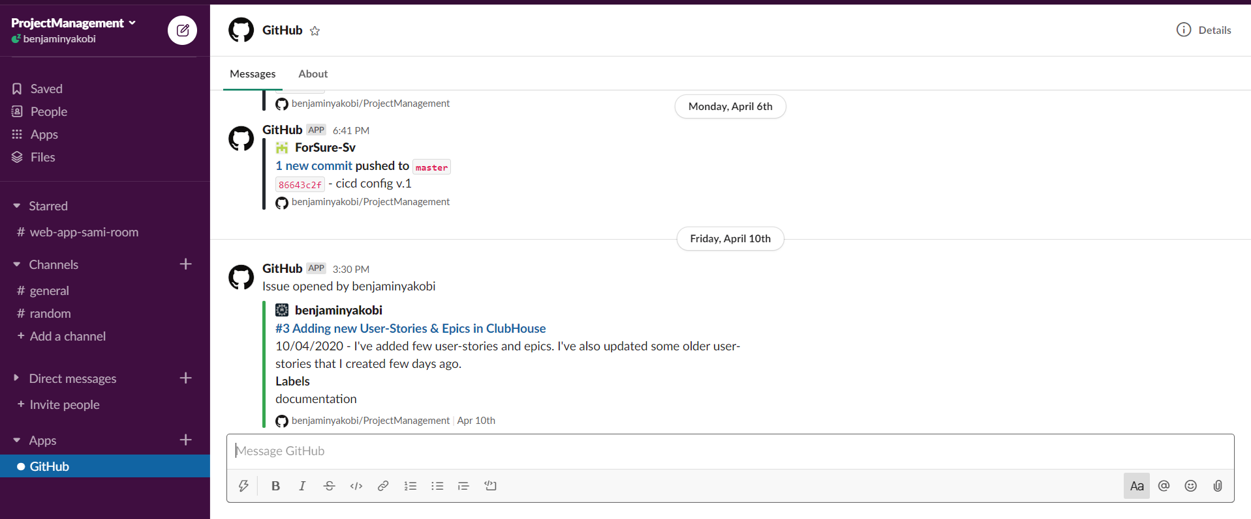

* 1. [CircleCi](https://app.circleci.com/pipelines/github/benjaminyakobi/ProjectManagement) & Screenshot:

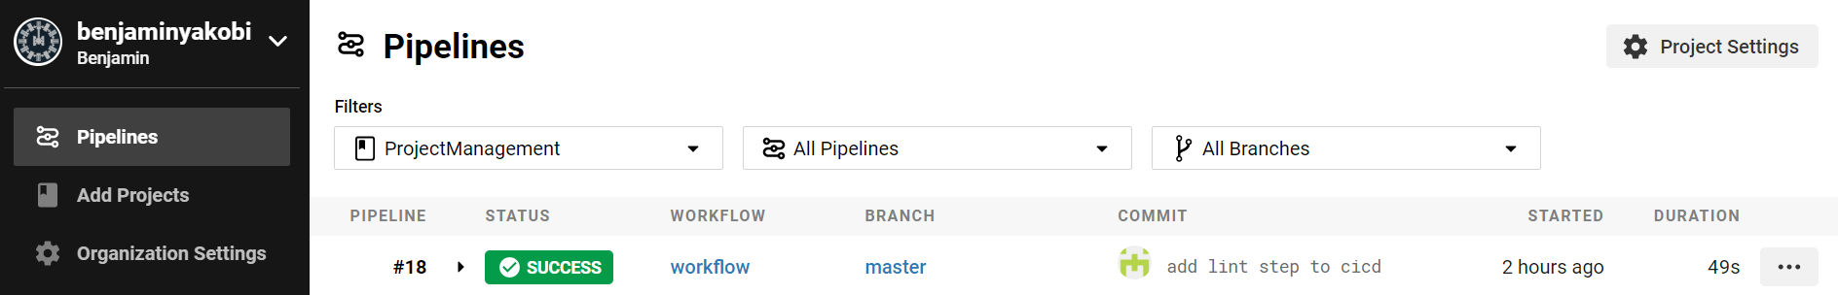

* 1. [Firebase](https://console.firebase.google.com/u/0/project/projectmanagement-612b8/overview) & Screenshot:

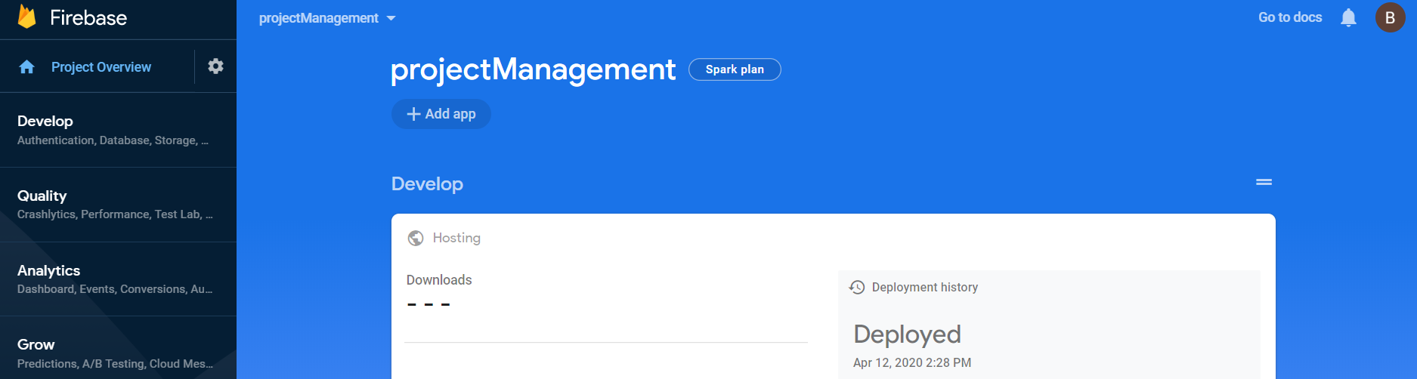

* + In this project we will use Firebase as Cloud service to store & run the project.
  + In this project we will use Firebase as our DB to save our data for the next sprints.